Peter the Great St. Petersburg Polytechnic University

Institute of Computer Science and Cybersecurity

Graduate School of Computer Technologies and Information Systems

**Lecture: Common Mistakes in SystemVerilog**

Subject: Automation of discrete device design (in English)

Completed by student of group 5130901/10101 Nepomnyaschij M.T.

(signature)

Lecturer Antonov A.P.

(signature)

Saint Petersburg

2023

**Table of contents**

SystemVerilog Unveiled: Navigating Complexities and Crafting Robust Code 4

Introduction to SystemVerilog Complexity 4

Part 1 4

Wire Assignments and the Evolution of Logic Types 4

Testing code and project compiling 5

1. Lecture code 5

2. Given code 6

Part 2 7

Variable Initialization and Behavioral Nuances 7

Testing code and project compiling 9

1. Lecture code 9

2. Given code 1 11

3. Given code 2 12

Part 3 14

Global variables 14

Testing code and project compiling 15

1. Lecture code 15

2. Given code 15

Part 4 17

Enumerated types 17

Testing code and project compiling 18

1. Lecture code 18

2. Given code 18

Part 6 20

Equality Operators: Unveiling Double Equals vs. Triple Equals 20

Testing code and project compiling 21

1. Lecture code 21

2. Given code 22

**List of illustrations**

Figure 1 – Wire and Logic types 4

Figure 2 - test.sv code listing 5

Figure 3 - Result of test.sv compilation 5

Figure 4 – sv_mist1.sv code compilation 6

Figure 5 – Result of sv_mist1.sv compilation 6

Figure 6 – Variable initialization demonstration 7

Figure 7 – Static and automatic differences 8

Figure 8 – Task calls 8

Figure 9 – test2.sv (static) code listing 9

Figure 10 – Result of test2.sv (static) compilation 9

Figure 11 – test2.sv (automatic) code corrections 10

Figure 12 – Result of test2.sv (automatic) compilation 10

Figure 13 – sv_mist2_1.sv code listing 11

Figure 14 – Result of sv_mist2_1.sv compilation 11

Figure 15 – sv_mist2_2.sv code listing 12

Figure 16 – Result of sv_mist2_2.sv compilation (1) 12

Figure 17 – Result of sv_mist2_2.sv compilation (2) 13

Figure 18 – Global variables 14

Figure 19 – assignVar.sv code listing 15

Figure 20 – Result of assignVar.sv compilation 15

Figure 21 – sv_mist3.sv code listing 16

Figure 22 – Result of sv_mist3.sv compilation 16

Figure 23 – Enumerated types 17

Figure 24 – Examples of printing values 17

Figure 25 – enumt.sv code listing 18

Figure 26 – Result of enum.sv compilation 18

Figure 27 – sv_mist4.sv code listing 18

Figure 28 – Result of sv_mist4.sv compilation 19

Figure 29 – Types of equality operators 20

Figure 30 – Vector comparisons 20

Figure 31 – equal2.sv code listing 21

Figure 32 – Result of equal2.sv compilation 21

Figure 33 – sv_mist6.sv code listing 22

Figure 34 – Result of sv_mist6.sv compilation 22

# SystemVerilog Unveiled: Navigating Complexities and Crafting Robust Code

## Introduction to SystemVerilog Complexity

The lecture initiates a meticulous exploration of SystemVerilog, emphasizing the examination of inherent complexities. The instructional approach focuses on dissecting wire assignments, variable types, and nuanced intricacies surrounding task implementation. The overarching objective is to facilitate a profound comprehension of these complexities, enabling the establishment of best practices and proficiency in SystemVerilog programming.

# Part 1

## Wire Assignments and the Evolution of Logic Types

To set the stage, we delved into the historical context of Verilog, where the roles of wire and reg were distinct and well-defined. Wires were the conduits for connecting component instances, while regs served as local variable storage. With the evolution to SystemVerilog, the term reg has been replaced by logic, ushering in a new era. However, this transition introduces a layer of complexity, as logic not only serves as an equivalent to reg but also encapsulates a data type with four states (1, 0, x, z).

Unlike traditional Verilog, SystemVerilog allows for point-to-point connections using the logic type, thereby reducing the reliance on wires in specific scenarios. This alteration becomes particularly noteworthy in synthesizable designs, where the need for wires diminishes, especially when tri-state connections are absent.

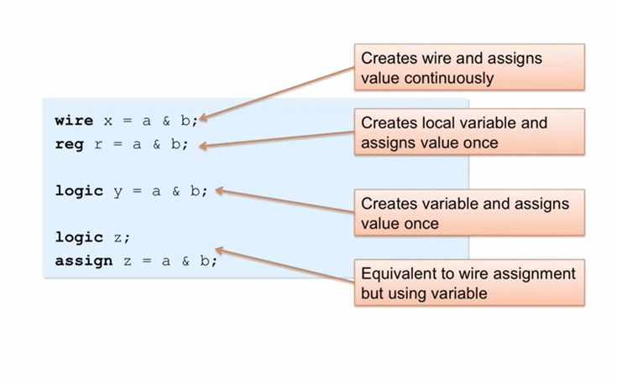

Figure 1 – Wire and Logic types

**The image demonstrates different ways to assign values to variables in programming:**

* **Continuous Assignment (wire):** Values update automatically when input variables change (like wires in a circuit).
* **Procedural Assignment (reg):** Values are assigned within code blocks and only change when explicitly updated.

## Testing code and project compiling

### Lecture code

Automatic variables emerge as a solution, ensuring unique instances for each task invocation, thereby mitigating inadvertent interactions. The simultaneous invocation of tasks from multiple processes is explored, shedding light on how variables behave within diverse scoping contexts.

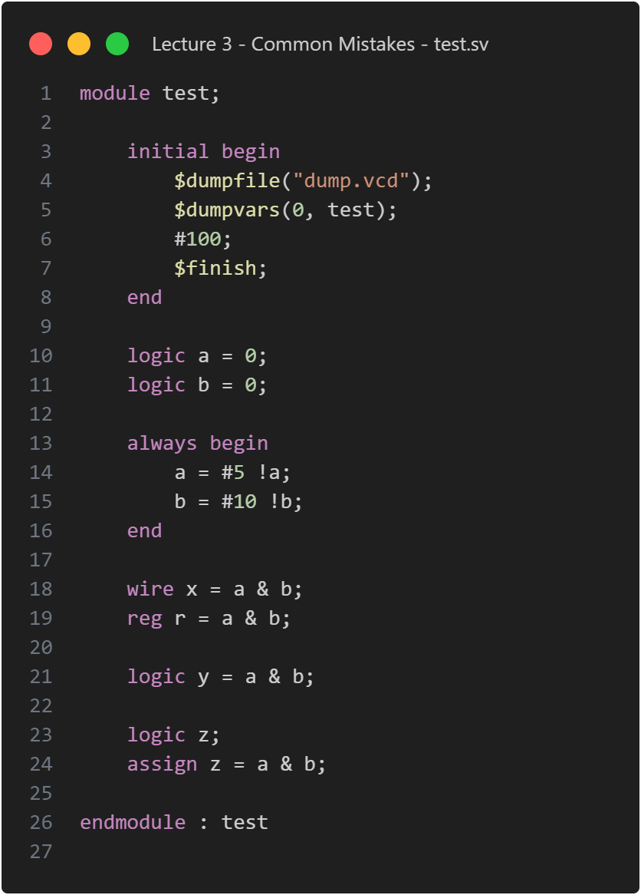

Figure 2 - test.sv code listing

By running the code, we can get the wave on the picture below:

Figure 3 - Result of test.sv compilation

This picture shows that whenever a and b are 1 at the same time the wire value (“x” on the wave) is also 1. The signal “z” acts the same which shows the identical operation of assign and wire logic.

If you want the signal to be just initialized of course you can just assign it like this but if you really do want it to act like the old wire assignments worked in the past you need to create the variable but then assign to the variable, as well.

### Given code

Figure 4 – sv_mist1.sv code compilation

By compiling the code we’ll get the wave which is presented on the picture below:

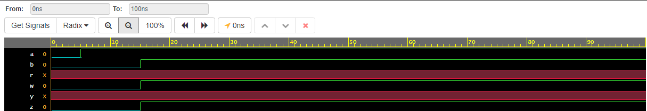

Figure 5 – Result of sv_mist1.sv compilation

As we can see, the given code is working correctly. So, when both a and b = 1 => w and z have value 1.

# Part 2

## Variable Initialization and Behavioral Nuances

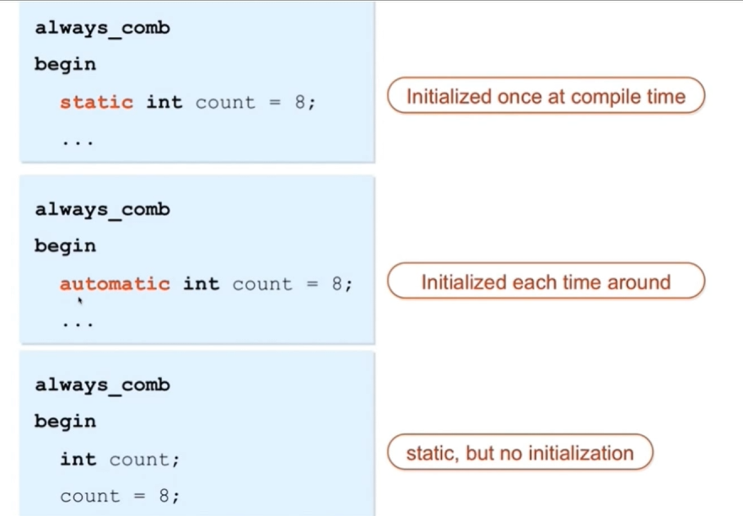

Figure 6 – Variable initialization demonstration

1. Static Variable Initialization (default):

* This variable is initialized once at compile time.
* It retains its value across multiple invocations of the block.
* Useful for maintaining state across function calls or procedural blocks.

1. Automatic Variable Initialization:

* This variable is initialized each time it’s encountered during execution.
* It’s suitable for temporary local storage within a block.

1. No Qualifier (Implicit Static):

* It is treated as static, but not automatically initialized.
* The value of count is assigned later in the code.

In summary, “static” ensures persistence across invocations, while “automatic” initializes per execution cycle. The third case is static but lacks automatic initialization.

In other words: Static tasks are scrutinized for their potential to create shared variables across multiple invocations, leading to unforeseen interactions. Automatic tasks emerge as a remedy, fostering task-specific variable instances.

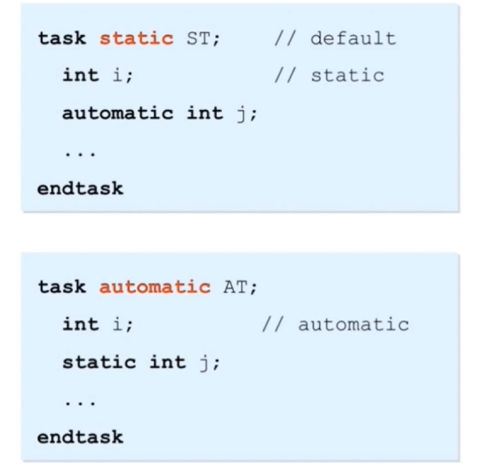

Figure 7 – Static and automatic differences

If you have a static task which again is the default, then any variables in the task itself are also going to be static so "i" in this case is going to be a static variable.

If you call task ST multiple times from multiple always blocks or multiple initial blocks every one of those invocations of ST, they share the same variable "i" so if one invocation updates "i" that updated value will be seen by the other one when it runs.

So that can be sort of non-intuitive trying to reuse a task repeatedly to do some common operation. If you don't want that behavior to happen, you can set a particular variable to be automatic and that means that every invocation of ST in this case will have its own copy of variable "j". okay so that's not shared among the different calls. If you have an automatic task that means that all the variables are automatic by default, so in this case the variable "i" in every invocation of that AT in this case will be unique – they'll have their own copy. But now "j" since it's static will be shared among all the AT implications.

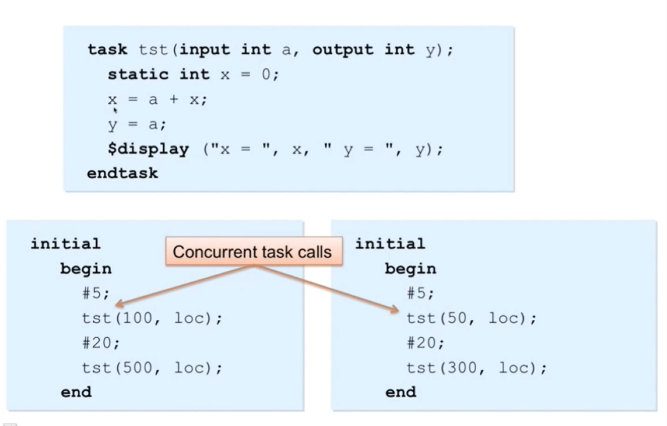

Figure 8 – Task calls

The idea is that we're going to have two concurrent initial blocks, so both are running concurrently in the simulator and then we're going to be calling the test task from each of them and they're going to be at the same time. So, the question is which one is going to be invoked first. That's really tool dependent. The point is that now these two tasks are actually called at time five, but we don't know the order and then that we wait 20 and we'll call them again… This is an example of calling the same task from multiple processes. An initial block serves as a process, and in this demonstration, we observe how a variable is shared between them, particularly when they are static versus automatic.

## Testing code and project compiling

### Lecture code

So, we will start by selecting the static variable case. In this case, we have a task named "test" with inputs a and output y, where x is declared as static and initialized to zero. The logic within the task involves updating x and y. Two initial blocks are set up to run this task concurrently.

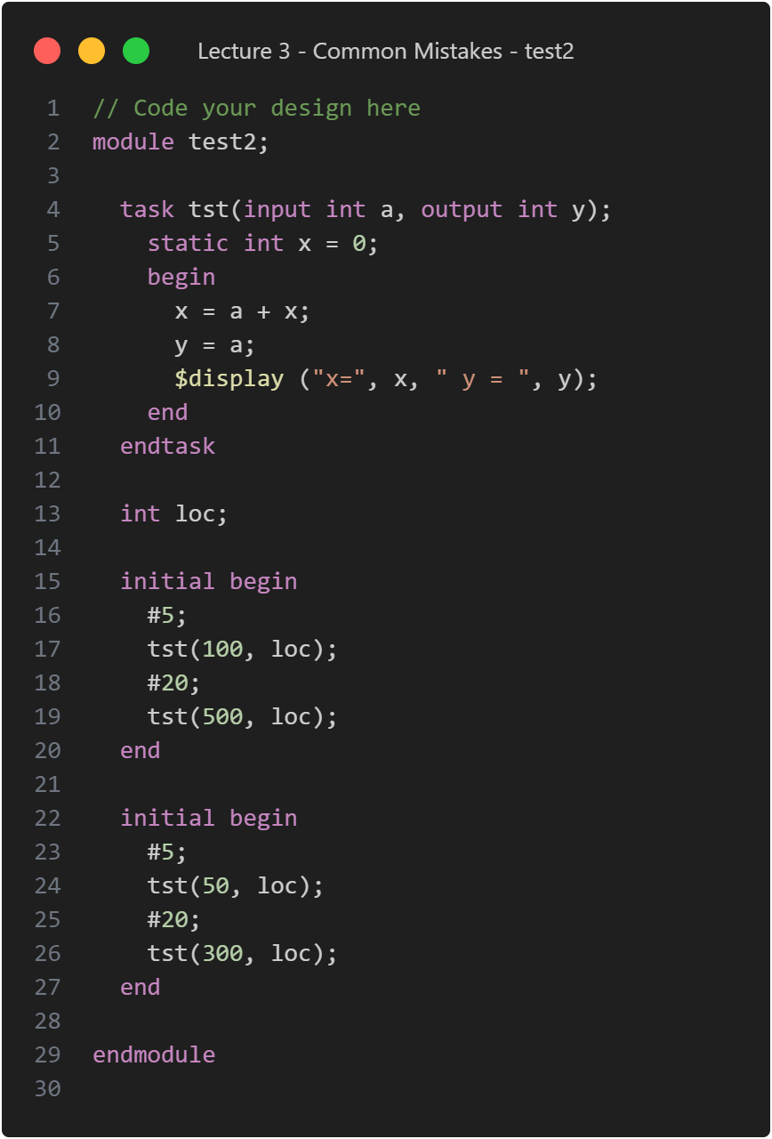

Figure 9 – test2.sv (static) code listing

Upon execution, with x being static and shared between the two calls, the results demonstrate that the first instance completes with x reaching a hundred, and y also equals a hundred. Subsequently, the other instance runs, producing its outcome.

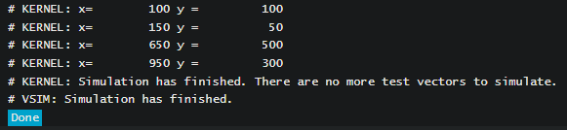

Figure 10 – Result of test2.sv (static) compilation

So, it ran the first instance with a value of one hundred, and then it executed the second one with 50. You can observe that x retains the value from the initial invocation because it's already at a hundred. Consequently, when we add the 50, it becomes 150. After a 20-unit delay, it appears that, once again, it ran the first initial block. This time, the value of x is 500. Adding this to the previous 150 gives us 650. Subsequently, it executed the second initial block, where another 300 was added.

This demonstration illustrates that the value of x is shared among all the different calls. Consequently, when it gets updated, the successive calls utilize this updated value.

Now let’s change static to automatic:

Figure 11 – test2.sv (automatic) code corrections

The result of compilation is shown below:

Figure 12 – Result of test2.sv (automatic) compilation

It seems that the first call ran first, and as a result, x becomes a hundred. However, in the subsequent call, when it runs at the bottom, it begins with x being zero. This discrepancy arises because it has its own copy of the variable x, designated as automatic. As a result, the x value does not increment in this case since it is not shared. The key takeaway here is that if you desire variables to be shared across different tasks, although this may not be a common scenario, you can declare them as static. On the other hand, if you wish for each task to possess its own unique value, then declaring them as automatic is the appropriate choice.

### Given code 1

Figure 13 – sv_mist2_1.sv code listing

This code defines a module with two always_comb blocks demonstrating the usage of static and automatic variables. The static variable (cnt_S) retains its value across multiple calls, while the automatic variable (cnt_A) is re-initialized in each call. The code also includes an initial block with a test sequence for variables x and y, displaying the values and cumulative counts of cnt_S and cnt_A at each step, and stopping after three iterations.

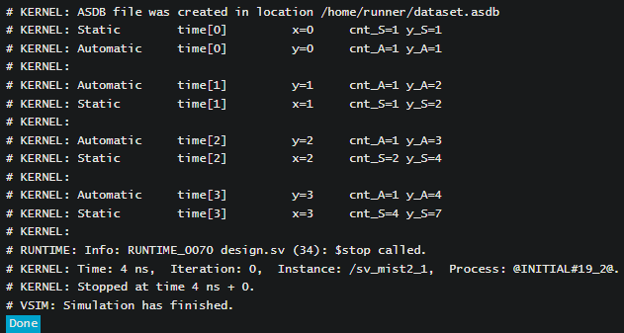

Figure 14 – Result of sv_mist2_1.sv compilation

This code is like the test2 code from the lecture, so we can see again that it works well.

### Given code 2

Figure 15 – sv_mist2_2.sv code listing

This SystemVerilog code above presents a module with two always_ff blocks illustrating the use of static and automatic variables in a clocked context. The static variable (cnt_S) retains its value across clock cycles, while the automatic variable (cnt_A) is re-initialized in each clock cycle. The code includes an embedded test with a clock signal (CLK), displaying the values of y_A and y_S after each positive clock edge. The simulation stops after 7 clock cycles.

The result of compiling is presented on the picture below:

Figure 16 – Result of sv_mist2_2.sv compilation (1)

Figure 17 – Result of sv_mist2_2.sv compilation (2)

Simulation runs for 7 clock cycles, showing the behavior of static and automatic variables in a clocked context. The embedded test displays cumulative counts of y_A and y_S after each positive clock edge. As we can see, all tests passed and the code works well.

# Part 3

## Global variab**les**

Figure 18 – Global variables

According to the picture above:

* Task aVar has an input val and an output outV.
* Two variables, globV and otherV (declared globally), are accessible within the task’s scope.
* When calling aVar, globV immediately receives the value of val.
* However, outV updates after a 10-unit delay, affecting otherV only at the task’s end.
* This timing discrepancy can be confusing: outV doesn’t instantly impact otherV.

Here we have our code again. We've declared a global variable and another variable. Our task, which takes an input val and produces an output outV, includes assignments with a 10-unit delay. Additionally, an initial block that calls aVar with the decimal value 37 was created.

Subsequently, we make another call to aVar with the value 73. In essence, we are running two calls in this scenario. When we execute this code, we can observe the outcomes.

## Testing code and project compiling

### Lecture code

Figure 19 – assignVar.sv code listing

The result of compilation is the wave below:

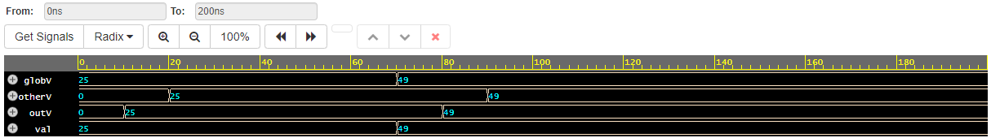

Figure 20 – Result of assignVar.sv compilation

So, we can observe that at time 0, we obtain the value 25. Indeed, if we inspect the moment when this task is called, specifically on 16th stroke without any pound delay, it occurs at time 0. Since there is no delay, the assignment to the global variable "globV" happens as the first action in the task, setting it immediately to the value 37, represented as 25 in hexadecimal.

However, a crucial point arises: when does the assignment to "outV" occur? Theoretically, it should happen after 10 units, as per the code. Yet, it waits another 10 units before concluding the task. This temporal distinction is vital to comprehend, as the assignment to "outV" occurs 10 units after the initial 10-unit delay. Indeed, "outV," the internal variable, is set after a delay of 10 units. However, the return value doesn't occur until 25 units. This pattern repeats when we alter the value to 73, which is equivalent to 49 in hexadecimal.

### Given code

As a result, the assignment to global variables within a task happens immediately upon task execution. However, the update of output values or variables designated as output parameters only occurs when the task concludes, not immediately after their assignment.

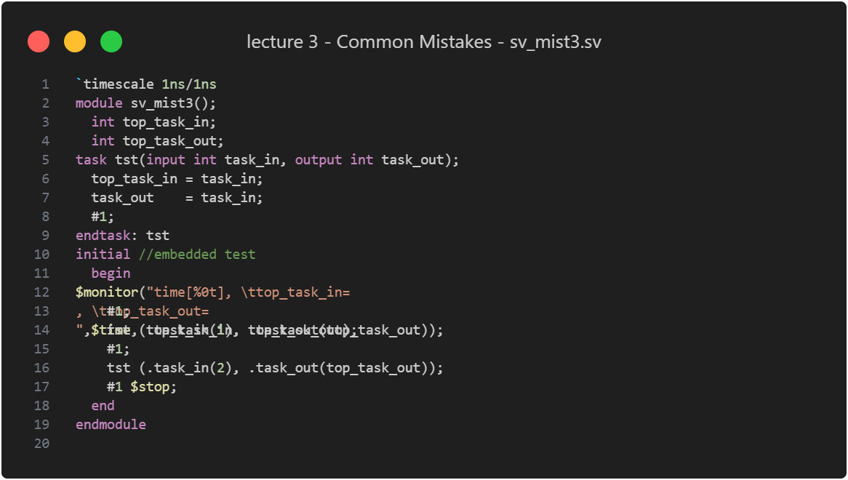

Figure 21 – sv_mist3.sv code listing

This SystemVerilog code defines a module (sv_mist3) with a task (tst) that takes an input parameter (task_in) and outputs a result (task_out). The initial block serves as an embedded test, calling the task twice with different input values and monitoring the top_task_in and top_task_out variables. The $monitor statement displays the time, top_task_in, and top_task_out during simulation. The simulation stops after the second task execution. Note that the output of the task (task_out) is assigned to top_task_out, and this assignment occurs after a delay of 1 time unit within the task.

Figure 22 – Result of sv_mist3.sv compilation

The output on the picture above displays the time, top_task_in and top_task_out during simulation. The embedded test calls the tst task twice with different inputs (1 and 2). There is a 1-time unit delay after each task invocation, impacting the assignment of top_task_out. top_task_in is assigned the value of task_in from the task. top_task_out is assigned the value of task_out from the task after the delay. The simulation stops after the second task execution.

# Part 4

## Enumerated types

There's a variable called "state" with values "idle," "starting," and "stopped," forming an enumerated type. Enumerated types are useful for enhancing code readability, especially in state machines or control systems. The recommended practice is to use a typedef to declare the enumerated type, making it easier to declare variables with clear names like "state_variable." This approach simplifies code comprehension and management. If you were to print out an enumerated type, you would see the defined values.

Figure 23 – Enumerated types

When using enumerated types in waveforms, you can visualize values like "idle," "start," and "stop," aiding in debugging state machines. However, when printing these values, the state names aren't automatically displayed. To achieve this, you need to implement a specific trick or method.

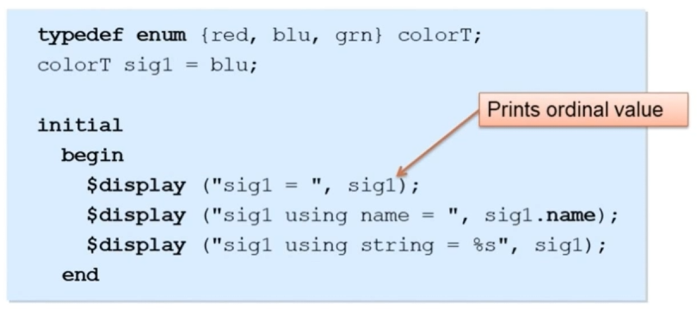

Figure 24 – Examples of printing values

We have a signal defined as a color type with red, green, and blue. We declare a signal named "sig1" of this color type and initialize it to be blue. This is a legal enumerated type, utilizing a typedef. However, when trying to print it using a dollar display, an issue arises. It displays the ordinal value (0 for red, 1 for blue, and 2 for green) instead of the desired red, green, or blue. To print the actual enumerated type of value, you can use "sig1.name" since "sig1" is of the enumerated type. This converts the value into the enumerated type, allowing you to see it printed as red, green, or blue, as intended. While some tools offer string formatting for this purpose, using the enumerated type of function is the recommended and standard approach.

## Testing code and project compiling

### Lecture code

Here's an example:

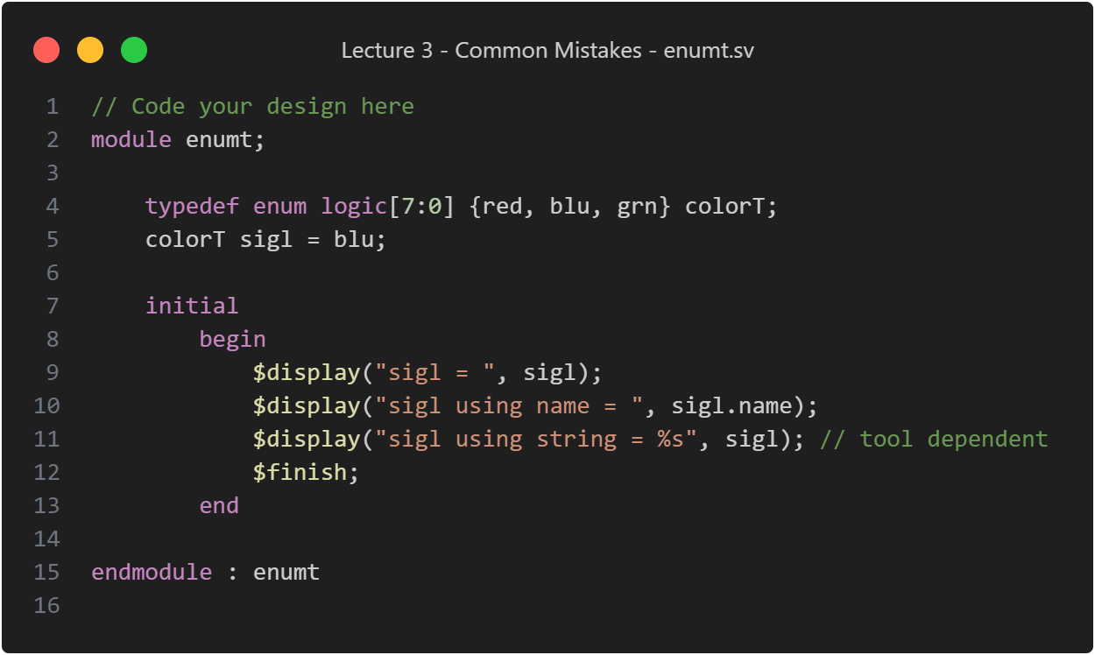

Figure 25 – enumt.sv code listing

We have a type defined as red, green, blue. In this case, we have a signal of that type initialized to blue. When we run this, the first printout shows that signal_one is equal to 1 because the ordinal value of blue is 1 (0 for red, 1 for blue, and 2 for green).

Figure 26 – Result of enum.sv compilation

To display the actual color name, we use "sigma.name," and now we correctly get "blue." The method of formatting as a string may depend on the tool, but following the standard and using the name attribute is the recommended approach.

### Given code

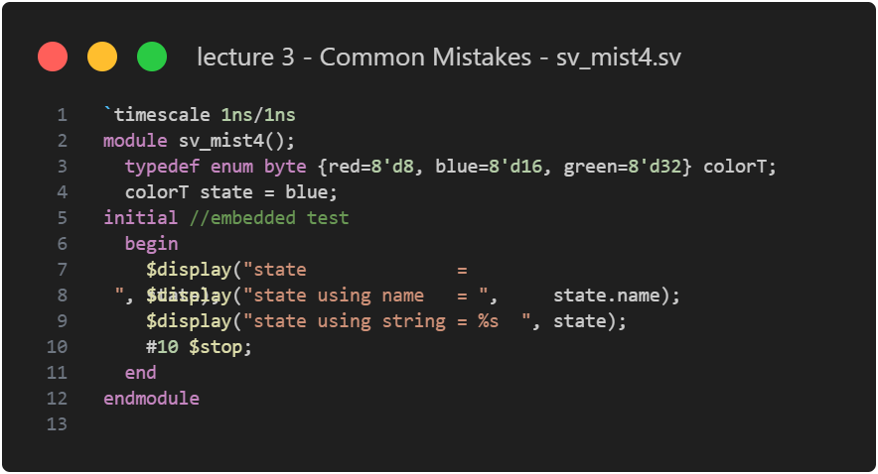

Figure 27 – sv_mist4.sv code listing

The module defines an enumerated type colorT with values red, blue, and green, each assigned a byte value. The variable state is initialized to blue. In an embedded test, information about state is displayed using decimal, name, and string formats.

Figure 28 – Result of sv_mist4.sv compilation

This code is like the lecture’s enumt.sv code, so it’s clear that it works well.

The output displays information about the state variable in different formats during simulation: decimal value, name attribute, and string representation. The code demonstrates the use of an enumerated type (colorT) with symbolic names (`red`, `blue`, `green`). The simulation stops after a delay of 10-time units.

# Part 6

## Equality Operators: Unveiling Double Equals vs. Triple Equals

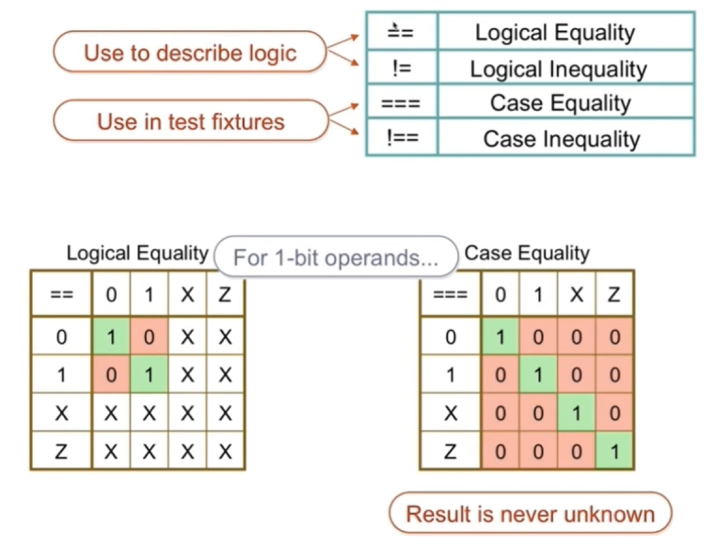

Figure 29 – Types of equality operators

The next mistake is the equality operators in SystemVerilog. There are double equals (==), exclamation point equals (!=), and triple equals (===), along with their not equal counterparts. The double equals checks for zeros and ones, resulting in an unknown value for cases like "0x" or "x0." This is acceptable for logical purposes but not ideal for checking design outputs in a test bench. For precise matching, especially in output checking, triple equals and exclamation point double equal are recommended. They ensure an exact match, and the result is never unknown.

The issue with unknown results is illustrated in vector comparisons:

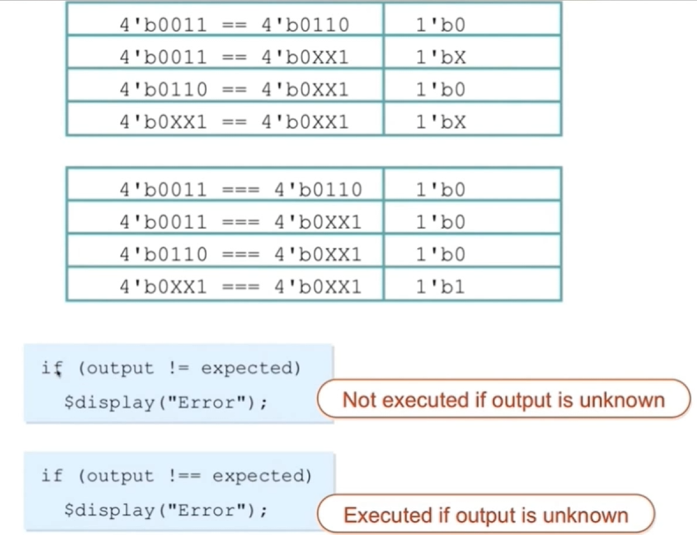

Figure 30 – Vector comparisons

For instance, with "0011" and "0xx1," the double equals might yield an unknown result, potentially masking errors in output checking. Using exclamation point double equal ensures failure when comparing designs with unexpected 'x' values.

## Testing code and project compiling

### Lecture code

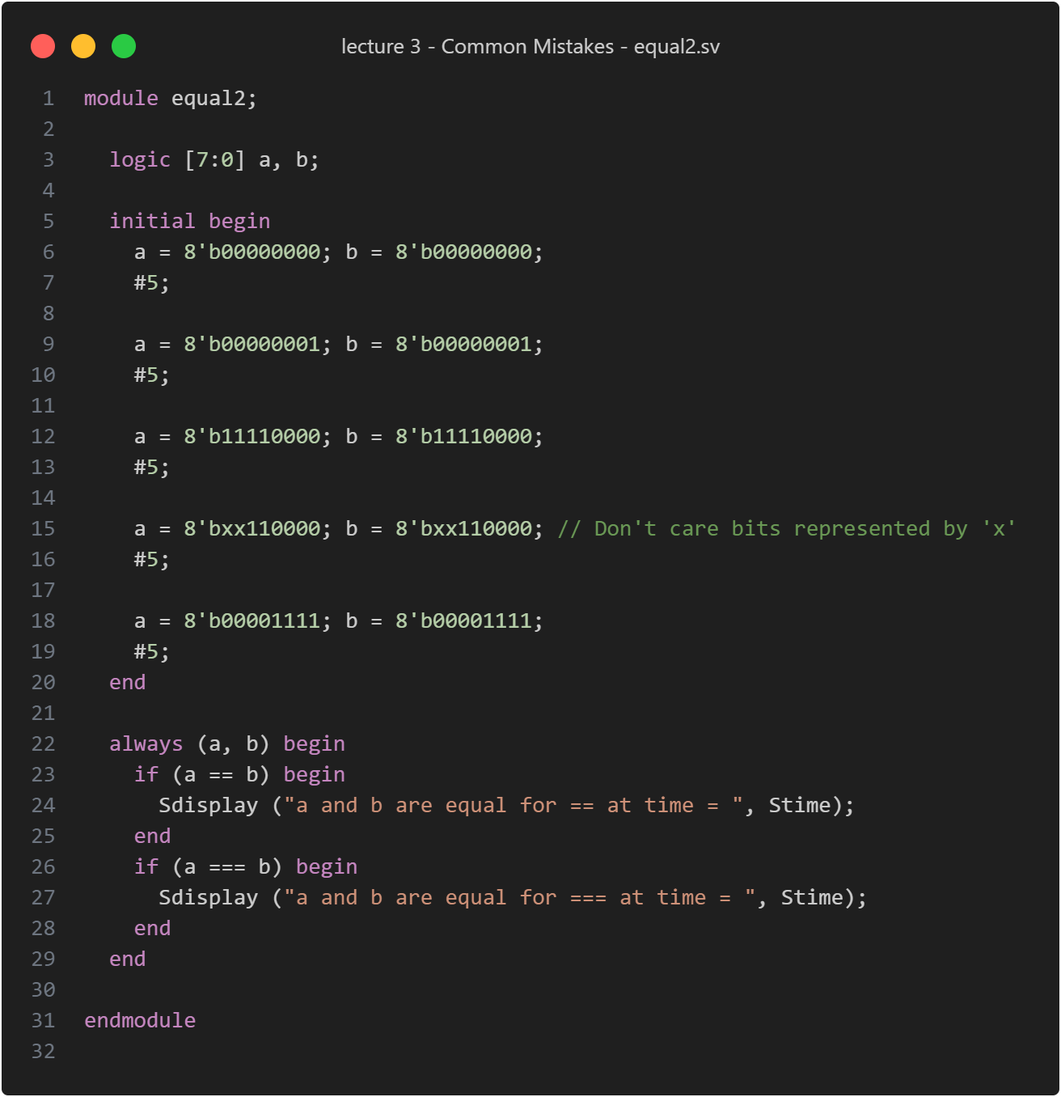

Figure 31 – equal2.sv code listing

In the provided example on the picture above, the comparison with triple equals provides accurate results, whereas double equals may fail to trigger the display due to unknown results. This demonstrates the importance of choosing the appropriate equality operator for precise and reliable output checking in SystemVerilog.

Figure 32 – Result of equal2.sv compilation

As a result, in vector comparisons, when using triple equals (===), it accurately compares even if there are 'x's present. However, with double equals (==), if 'x's are involved, the result becomes unknown, and the comparison doesn't trigger the if statement for further action, potentially leading to overlooked errors in output checking. Choosing the appropriate equality operator is crucial for precise and reliable results in SystemVerilog.

### Given code

Figure 33 – sv_mist6.sv code listing

This code is like equal2.sv file from the lecture one. After its compilation, we get the result presented on the picture below:

Figure 34 – Result of sv_mist6.sv compilation

The output shows the results of comparisons between logic vectors a and `b` using double equals (==) and triple equals (===) operators, as well as inequality using `!=` and `!==` operators. The code illustrates the differences in behavior between these operators in SystemVerilog. The embedded test sets different values for `a` and `b`, showcasing the outcomes of the comparisons. The simulation stops after the embedded test.